Weekly Assessment for Delta Operations on ESA and CESA-listed Salmonids and Osmerids including Current Delta Hydrologic Conditions
  - Last updated: Monday, January 12, 2026 at 8 AM
Table of contents

Executive Summary

ESA and CESA-listed Salmonids
- Entrainment management season is active.
- Season Loss: 0 (0.00% of threshold) DNA Winter-run, 0 (0.00% of threshold) Hatchery Winter-run, 17.93 (0.34% of threshold) Natural Steelhead, and 96.59 (2.71% of threshold) Hatchery Steelhead.
- Winter-run presence in the Delta is high (historical peak).
- Steelhead presence in the Delta is increasing.

ESA and CESA-listed Osmerids
- First flush conditions were met on 12/23/25, and the action was implemented on 12/25/25.
- The First flush action implementation period will end on 1/7/26, then other entrainment management actions will become active.
- Delta smelt are primarily distributed west of the confluence, in Suisun Marsh
- No Delta smelt or longfin smelt salvage has been observed this water year
- Turbidity in the central/south Delta is high

1 PRELIMINARY DATA: Current Delta Hydrologic Conditions

1.1 Operational and Regulatory Conditions
Entrainment management is the current controlling factor. See most recent weekly outlook for more information.

1.2 Current Conditions
Most recent inflow at Freeport in the Sacramento River and Vernalis in the San Joaquin River is 69,318 and 3,071 cfs respectively. Most recent 1-day, 5-day, and 14-day OMRI measurements were -4,900, -4,901, and -5,061 respectively, and most recent export data were 3,551 for Jones Pumping Plant and 1,734 for Henry O. Banks Pumping Plant.
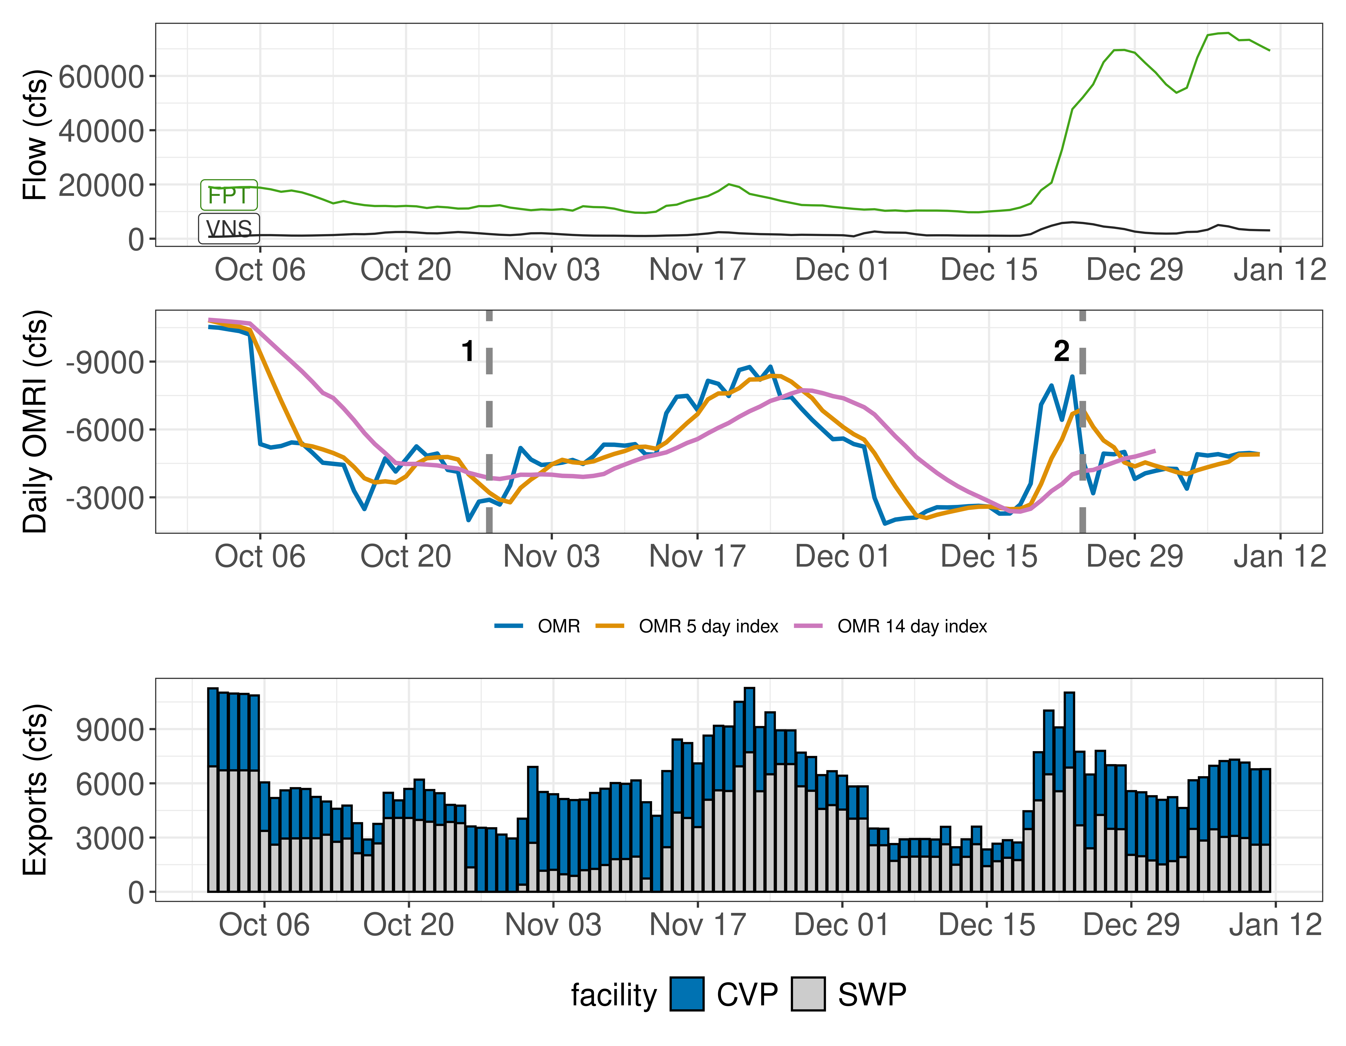
Figure 1: Operations and Action Summary, WY 2026. The colors in the OMRI plot indicate different types of triggers (see Table 1). OMRI data calculated by SacPAS, Freeport (FPT) and Vernalis (VNS) flow data from CDEC, and CVP (TRP) and SWP (HRO) exports data from CDEC.
Table 1: Summary of Actions and Triggers, WY 2026
Label | Action | Date Triggered | Date Implemented | Number Days Implemented | Regulation
1 | DCC Gate Closure | 10/28/2025 | 10/30/2025 | Ongoing | DCC gates
2 | First Flush | 12/24/2025 | 12/25/2025 | Ongoing | Entrainment Management

1.3 Zone of Influence
Zone of Influence (ZOI) analysis is discussed in detail in the December 22 assessment. Current conditions were queried from most recent Freeport flow data on the Sacramento River and Vernalis flow data on the San Joaquin river from SacPAS. Forecasted flows were queried from short range deterministic flows provided by the California Nevada River Forecast Center.
Current conditions at Freeport and Vernalis indicate that delta hydrology falls within the ‘himed’ category. Forecasted conditions averaged across the next 7 days falls within the ‘himed’ category.
The altered channel length for the current “himed” hydrology is 23, 53, 118 and 111 kilometers (km) across OMR bins of -2000, -3500, -5000 and <-5500 respectively. The altered channel length for forecasted “himed” hydrology is 23, 53, 118 and 111 kilometeres (km) across OMR bins of -2000, -3500, -5000 and <-5500 respectively.
Change in altered channel length between OMR levels is 88 km for current conditions and 88 km for forecasted conditions indicating that ZOI impacts across OMR scenarios would not change between current and forecasted conditions. Across the nine hydrology bins, changes in altered channel length across OMR scenarios are moderate (between 25th and 75th percentiles) for both current and forecasted hydrology.
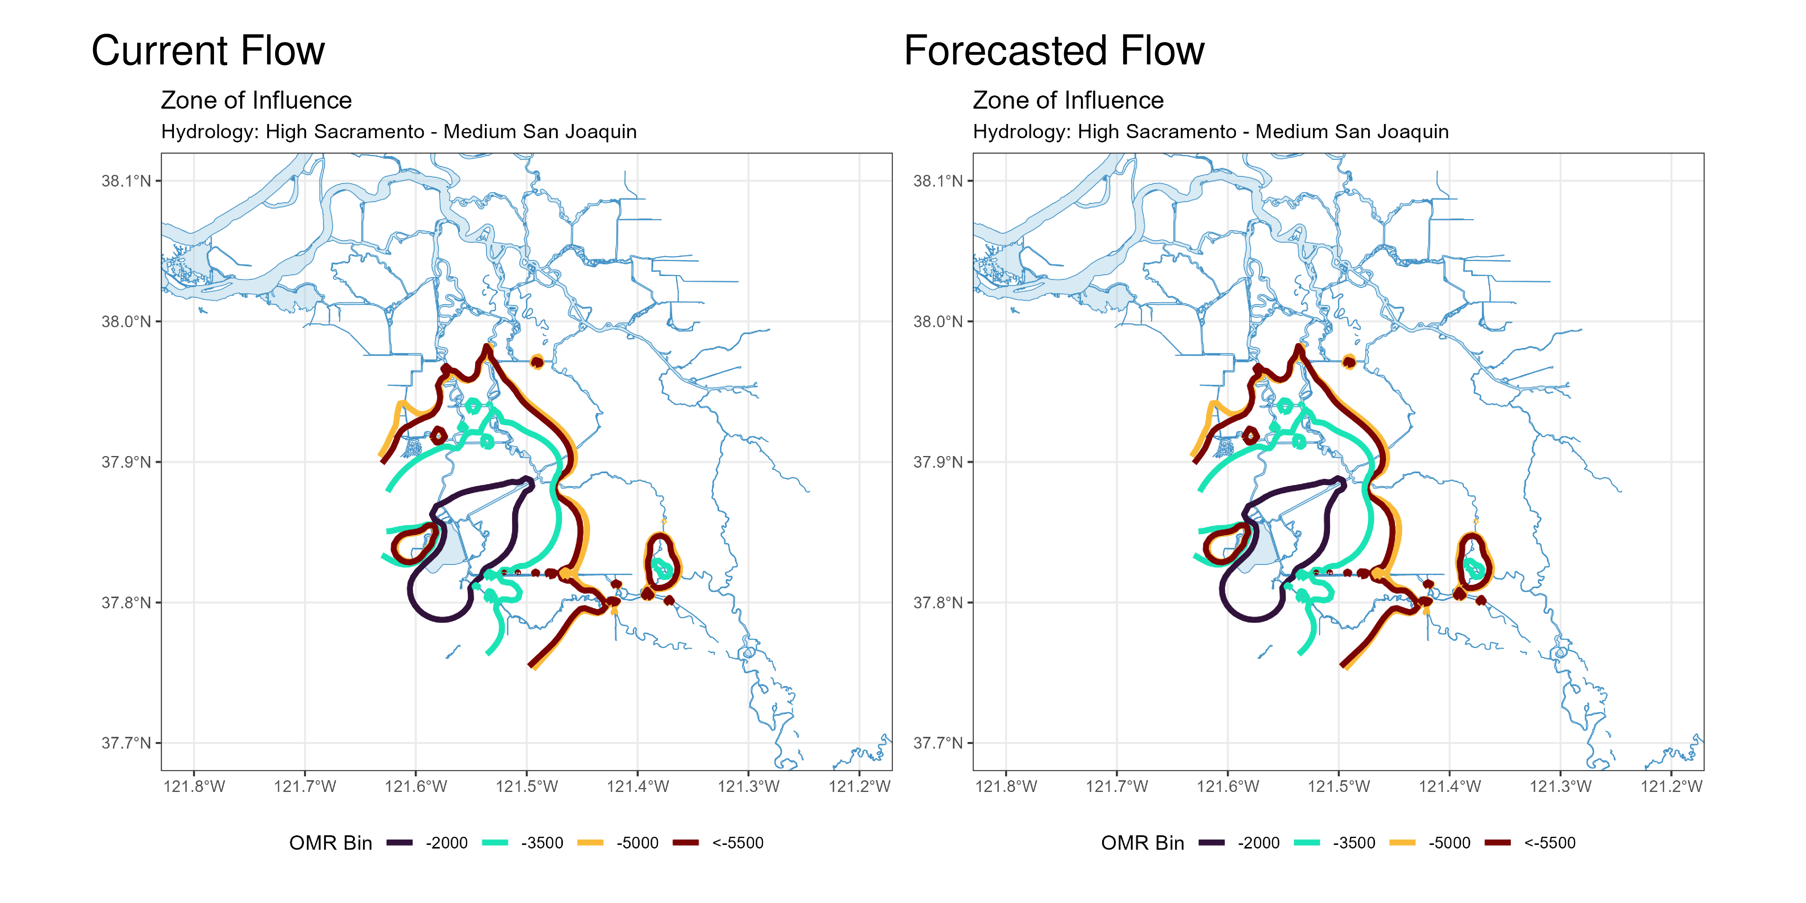
Figure 2: Modeled Zone of Influence at different OMRI scenarios based on current inflow hydrology (left) and forecasted inflow hydrology (right) from the Sacramento River and San Joaquin River

2 PRELIMINARY DATA: Assessment for Delta Operations on ESA and CESA-listed Salmonids
For more detailed data on salmonid conditions in the Delta see corresponding webpage on SacPAS.

2.1 Natural Winter-run Chinook

2.1.1 Juvenile Production Estimate
The Juvenile Production Estimate for winter-run is 1,057,452 for the current water year.

2.1.2 Current Status
Entry Timing - Historically, as of Jan 11, 74% of length-at-date (LAD) winter-run have entered the delta based on Knights Landing RST catch, 2% have exited the delta based on Chipps Island Trawl Catch, and 0% of DNA confirmed winter-run have been salvaged.
Table 2
Species | Red Bluff Diversion Dam | Tisdale RST | Knights Landing RST | Sac Trawl (Sherwood) | Chipps Island Trawl | Salvage
Chinook, LAD Winter-run, Unclipped | 98% | 76% | 74% | 38% | 2% | 14%
Chinook, DNA Winter-run, Unclipped (Water Year) | NA | NA | NA | NA | NA | 0%

Red Bluff Diversion Dam Passage Estimate - As of Dec 16 estimated passage to date of LAD winter run at Red Bluff Diversion is approximately 3.61 million fish. * Note that outmigration timing overlaps with spring run migrating fish, and true winter-run abundance likely differs from these estimates.
Delta Monitoring - Total catch of LAD winter run at RSTs at Delta Entry (Tisdale, Knights Landing, Lower Sacramento River) between Dec 28 and Jan 08 is 168 individuals. Total catch at Sacramento Trawl and Beach Seines in the delta between Dec 29 and Jan 08 is 19 individuals. Total catch at Delta Exit at Chipps Island between Dec 29 and Jan 08 is 1 individuals.

2.1.3 Annual Loss
The annual Loss threshold for natural winter-run is 1% of the jpe or 10,574.52 fish. As of January 11, cumulative loss of genetically confirmed winter-run is 0 or 0.00% of the annual loss threshold. Cumulative loss in the past 7 days has been 0.
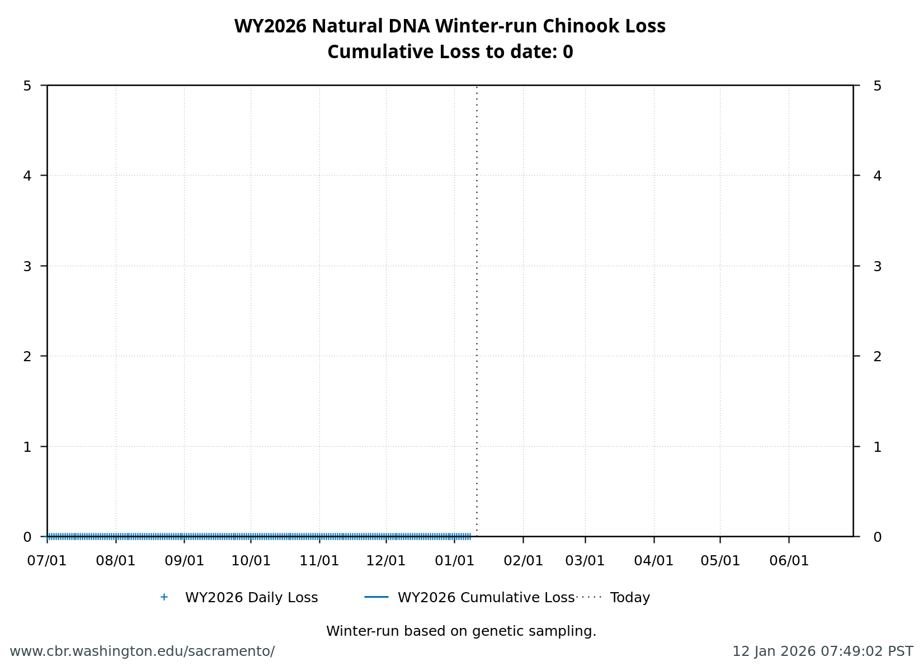
Figure 3

2.1.4 STARS
The Delta STARS Model is an individual-based simulation model that predicts survival, travel time, and routing of juvenile salmon migrating through the Sacramento–San Joaquin River Delta. This model gives insight into survival and routing patterns of winter-run based on most current conditions.
As of January 10, overall through delta STARS estimated survival probability (with 80% credible intervals) is 0.72 (0.64-0.8) placing it in the 93rd percentile of historical STARS survival estimates for the month of January (WYs 2018-2025). STARS estimated routing and survival probabilities (with 80% credible intervals) into the interior delta are 0.04 (0.03-0.05) and 0.74 (0.62-0.85), respectively, corresponding to the 4th and 93rd percentiles of historical January estimates (WYs 2018-2025).
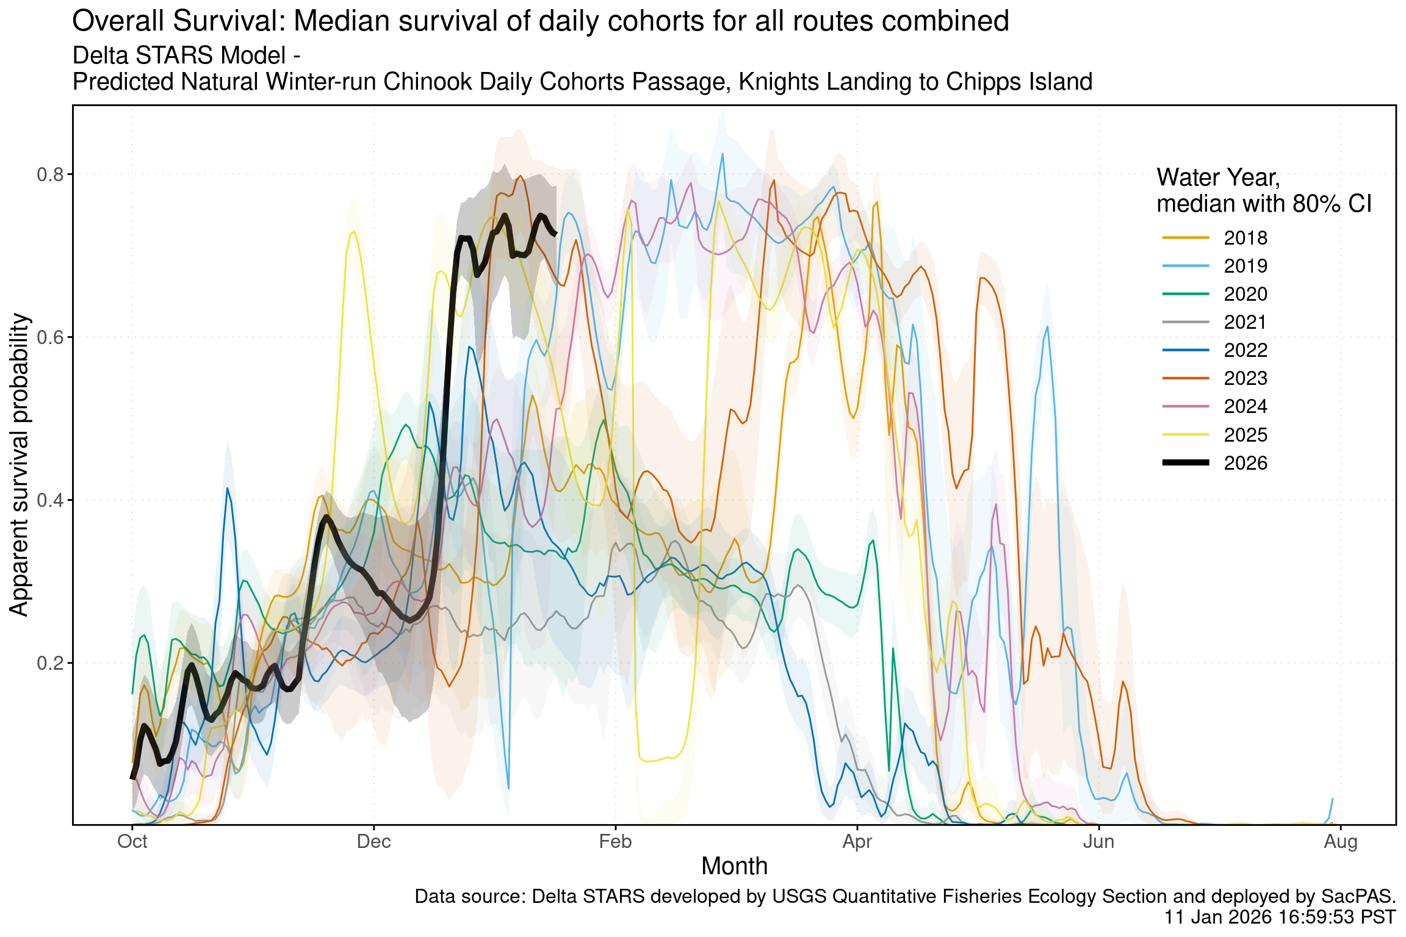
Figure 4
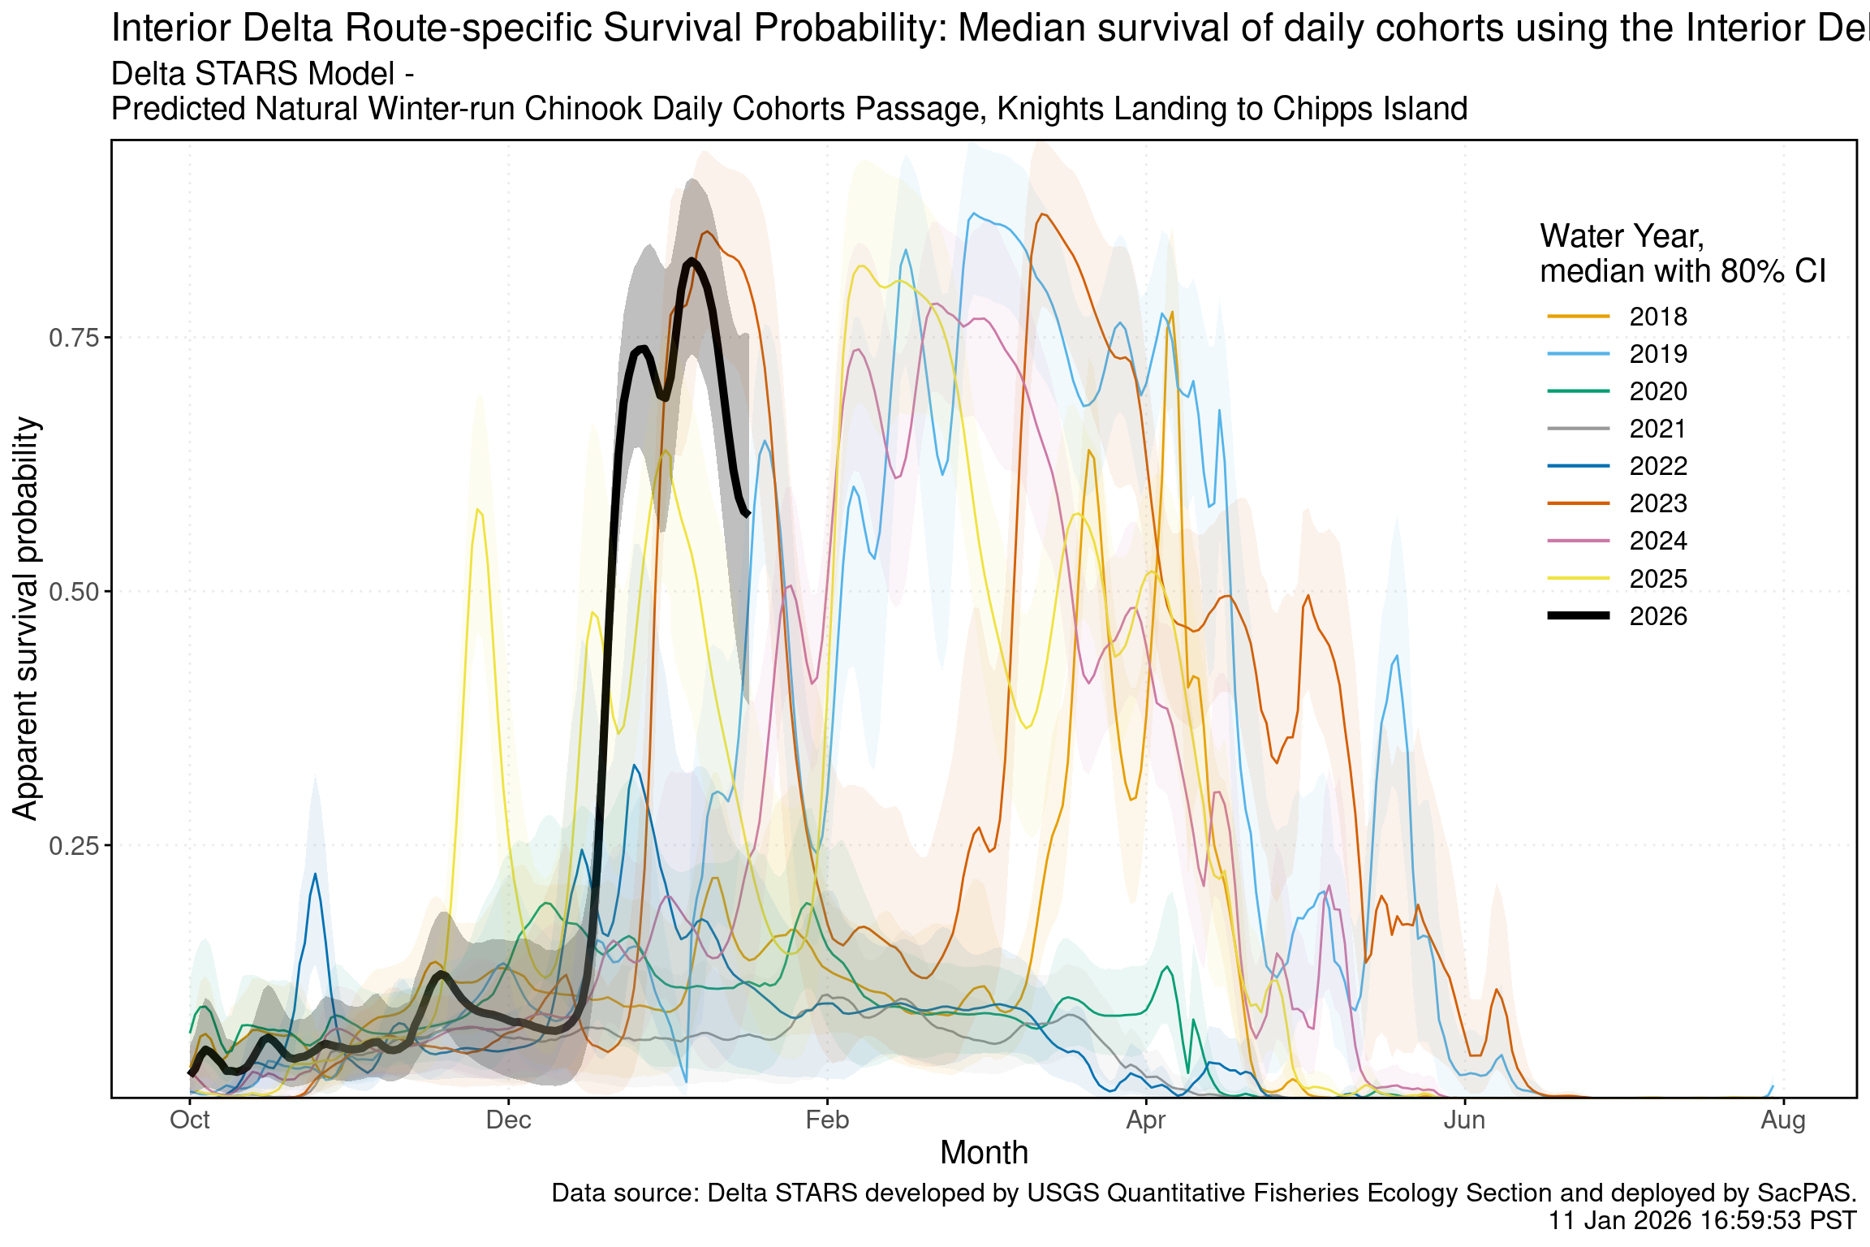
Figure 5
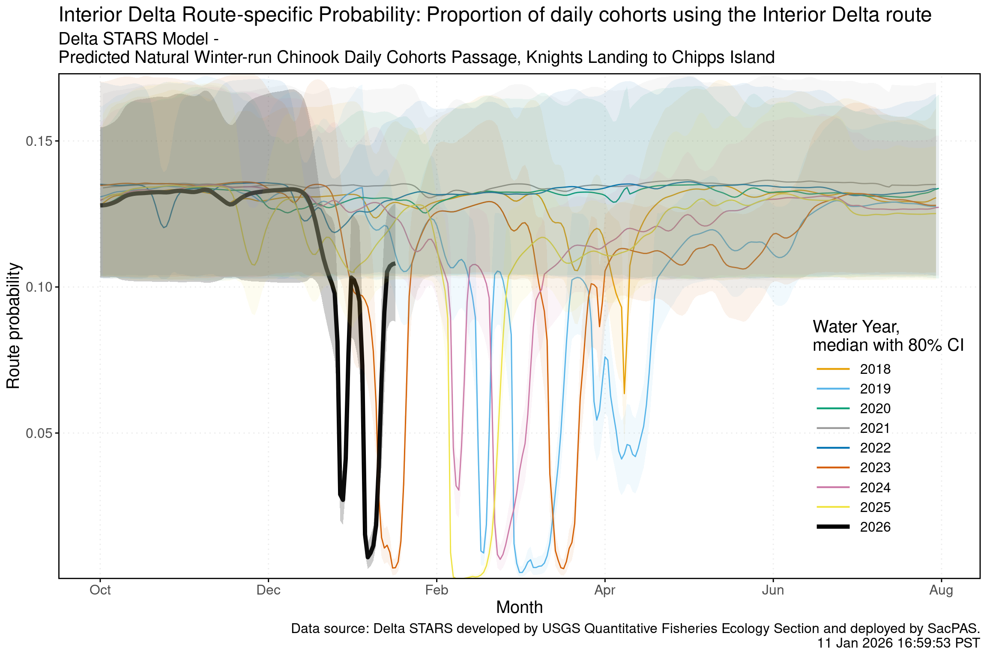
Figure 6

2.2 Hatchery Winter-run Chinook

2.2.1 Hatchery Releases
To date, no winter-run Livingstone hatchery releases have occurred in WY 2026

2.2.2 Juvenile Production Estimate
The Juvenile Production Estimate for hatchery winter-run is 130,096 for Livingston Stone releases.

2.2.3 Annual Loss
To date, no loss has occurred as no hatchery winter-run have been released.

2.3 Natural-origin Central Valley Steelhead

2.3.1 Current Status
Delta Entry Timing - Historically, as of Jan 11, 16% of CCV steelhead have entered the delta based on Knights Landing RST catch, 1% have exited the delta based on Chipps Island Trawl Catch, and 6% have been salvaged.
Table 3: Average Percent of annual emigrating population for unclipped CCV steelhead captured at the following locations and salvaged at SWP and CVP Delta facilities for the past 10 years.
Species | Red Bluff Diversion Dam | Tisdale RST | Knights Landing RST | Sac Trawl (Sherwood) | Chipps Island Trawl | Salvage
Steelhead, Unclipped | 1% | 12% | 16% | 0% | 1% | 6%

Delta Monitoring - Total catch of LAD winter run at RSTs at Delta Entry (Tisdale, Knights Landing, Lower Sacramento River) between Dec 28 and Jan 08 is 0 individuals. Total catch at Sacramento Trawl and Beach Seines in the delta between Dec 29 and Jan 08 is 0 individuals. Total catch at Delta Exit at Chipps Island between Dec 29 and Jan 08 is 0 individuals.

2.3.2 Annual Loss
As of January 11, cumulative loss of unclipped steelhead is 17.93 or 0.34% of the incidental take limit in the NMFS Biological Opinion. Cumulative loss in the past 7 days has been 74.83.
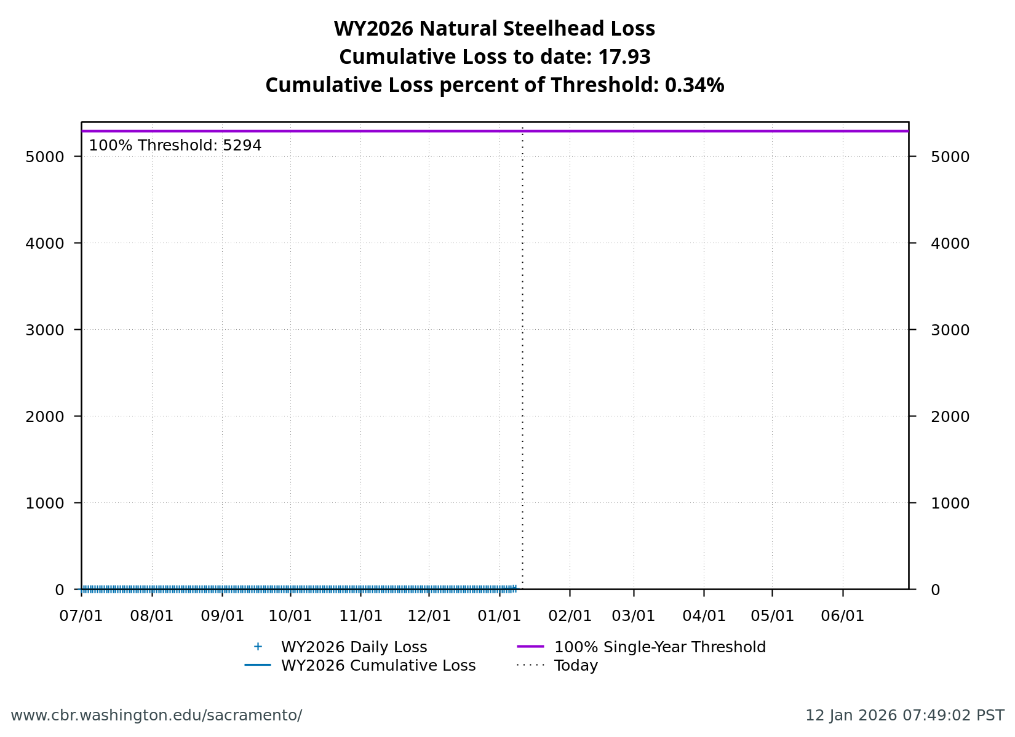
Figure 7

2.4 Hatchery-origin Central Valley Steelhead

2.4.1 Surrogate Releases
There have been a total of 2 releases totaling 878,848 steelhead in Water Year 2026. JPE for the hatchery releases as of today is 356,526 based on estimated survivals using forecasted water year types (see details in table below). The annual loss threshold, equal to 1% of the JPE, is currently 3565, but is subject to change with additional steelhead releases.
Table 4: Summary of steelhead hatchery releases in Water Year 2026
Hatchery | Date of Release | Mean Fork Length (mm) | Number Released | Estimated Survival | Juvenile Production Estimate
Nimbus | 2025-11-02 | 223 | 233,109 | 72% | 167,838
Coleman | 2025-12-19 | 195 | 645,739 | 29% | 188,688

Total loss of hatchery-origin steelhead is 96.59 or 2.71% of the threshold. *Note that hatchery origin of salvaged fish can not be determined at this time and salvage is based on the assumption of similar routing and survival probabilities of individual hatchery releases.
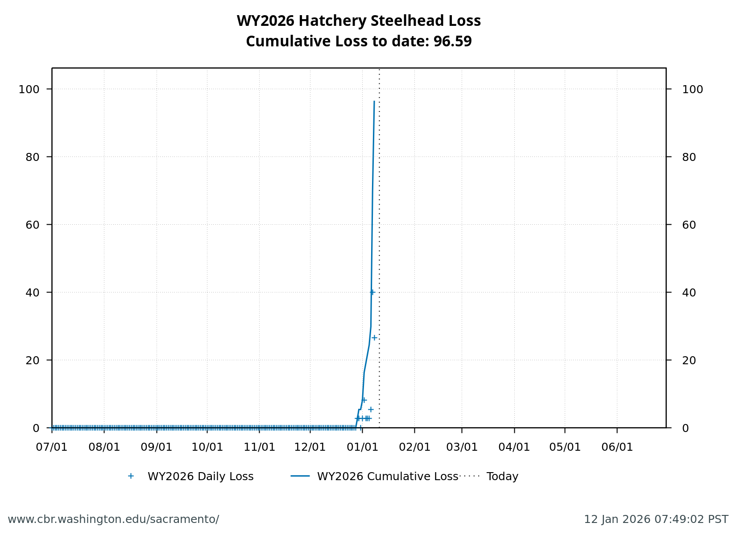
Figure 8

2.5 Spring-run

2.5.1 Current Status
Delta Entry Timing- Historically, as of Jan 11, 26% of LAD spring run have entered the delta based on Knights Landing RST catch, 0% have exited the delta based on Chipps Island Trawl Catch, and 0% have been salvaged.
Table 5: Average Percent of annual emigrating population for LAD Spring-run Chinook Salmon captured at the following locations and salvaged at SWP and CVP Delta facilities for the past 10 years.
Species | Red Bluff Diversion Dam | Tisdale RST | Knights Landing RST | Sac Trawl (Sherwood) | Chipps Island Trawl | Salvage
Chinook, LAD Spring-run, Unclipped | 12% | 13% | 26% | 2% | 0% | 0%

Red Bluff Diversion Dam Passage Estimate - As of Dec 16 estimated passage to date of LAD spring run at Red Bluff Diversion is approximately 0.01 million fish. * Note that outmigration timing overlaps with winter run and fall run outmigration, and true spring run abundance likely differs from these estimates.
Delta Monitoring- Total catch of LAD winter run at RSTs at Delta Entry (Tisdale, Knights Landing, Lower Sacramento River) between Dec 28 and Jan 08 is 137 individuals. Total catch at Sacramento Trawl and Beach Seines in the delta between Dec 29 and Jan 08 is 0 individuals. Total catch at Delta Exit at Chipps Island between Dec 29 and Jan 08 is 0 individuals.

2.5.2 Surrogate Releases
A total of 193,101 yearling surrogate fish have been released across 3 releases and a total of 0 young-of-year surrogate fish have been released across 0 releases. See details in table below.
Table 6: Spring-run Chinook Salmon Hatchery Surrogate Summary Table.
Type | Hatchery | Release Start | Release End | Race | # of CWT Fish Released | Loss Threshold (1% of CWT Released) | Loss (% of threshold)
Yearling | Coleman NFH | 2025-11-17 | 2025-11-17 | Late-Fall | 75119 | 751.19 | 0 (0.00%)
Yearling | Coleman NFH | 2025-12-22 | 2025-12-22 | Late-Fall | 60873 | 608.73 | 97.1 (0.16%)
Yearling | Coleman NFH | 2026-01-08 | 2026-01-08 | Late-Fall | 57109 | 571.09 | 0 (0.00%)

2.6 Evaluation
- What is the probability of exceeding natural or hatchery winter-run Chinook Salmon loss thresholds in the upcoming week?
- What is the probability of spring-run hatchery Chinook Salmon loss thresholds in the upcoming week?
- What is the probability of spring-run hatchery Chinook Salmon loss thresholds in the upcoming week?

2.7 References

3 Weekly Assessment for Delta Operations on ESA and CESA-listed Osmerids

3.1 Operational and Regulatory Conditions
- See current Weekly Fish and Water Operations Outlook document.
- Additional information also available on the SacPAS SMT page.

3.2 Delta smelt

3.2.1 Biological
- Delta smelt life stages: Adult, Juvenile
- Abundance estimate: 6821 (95% CL: 1,477 to 20,185) as of the week of December 29, 2025–January 2, 2026
- Releases: A total of 163,349 cultured Delta smelt have been released for WY 2026. The most recent release of 24,606 fish occurred in Sacramento River at Rio Vista on Dec 16, 2025.
- Delta smelt count: 33 adult Delta smelt and 24 juvenile Delta smelt have been detected this water year. See Table 7 for recent detections, Figure 9 for spatial distribution, and Figure 10 for temporal distribution.
- Delta smelt salvage: 0 Delta smelt have been salvaged, and the cumulative seasonal salvage is 0.
Notes
- Since there are few recent detections of Delta smelt, estimation of distribution within the Delta is limited.
- As mentioned in EDSM reporting, fork length ranges reported for Delta smelt and longfin smelt life stages are defined by permit reporting purposes and are not intended to delineate cohorts or distinguish from hatchery or wild origin. See Table 7 caption for fork-length ranges for age groups of Delta smelt.
- See SacPAS SMT Page for additional details on releases and detection in surveys and salvage.
- Historical salvage trends can be found at: SacPAS Salvage Timing
Table 7: Delta smelt detections in the last 2 weeks. Fork Length > 58mm = Adult, Fork Length 20-58mm = Juvenile, Fork Length < 20mm = Larva.
Survey | Date | Region | Stratum | Life Stage | Catch
EDSM | 2026-01-02 | West | Suisun Marsh | Adult | 2
EDSM | 2026-01-02 | West | Suisun Marsh | Juvenile | 1
EDSM | 2026-01-07 | West | Suisun Marsh | Adult | 1
EDSM | 2026-01-07 | West | Suisun Marsh | Juvenile | 1
EDSM | 2026-01-08 | West | Suisun Marsh | Adult | 3
EDSM | 2026-01-08 | West | Suisun Marsh | Juvenile | 1

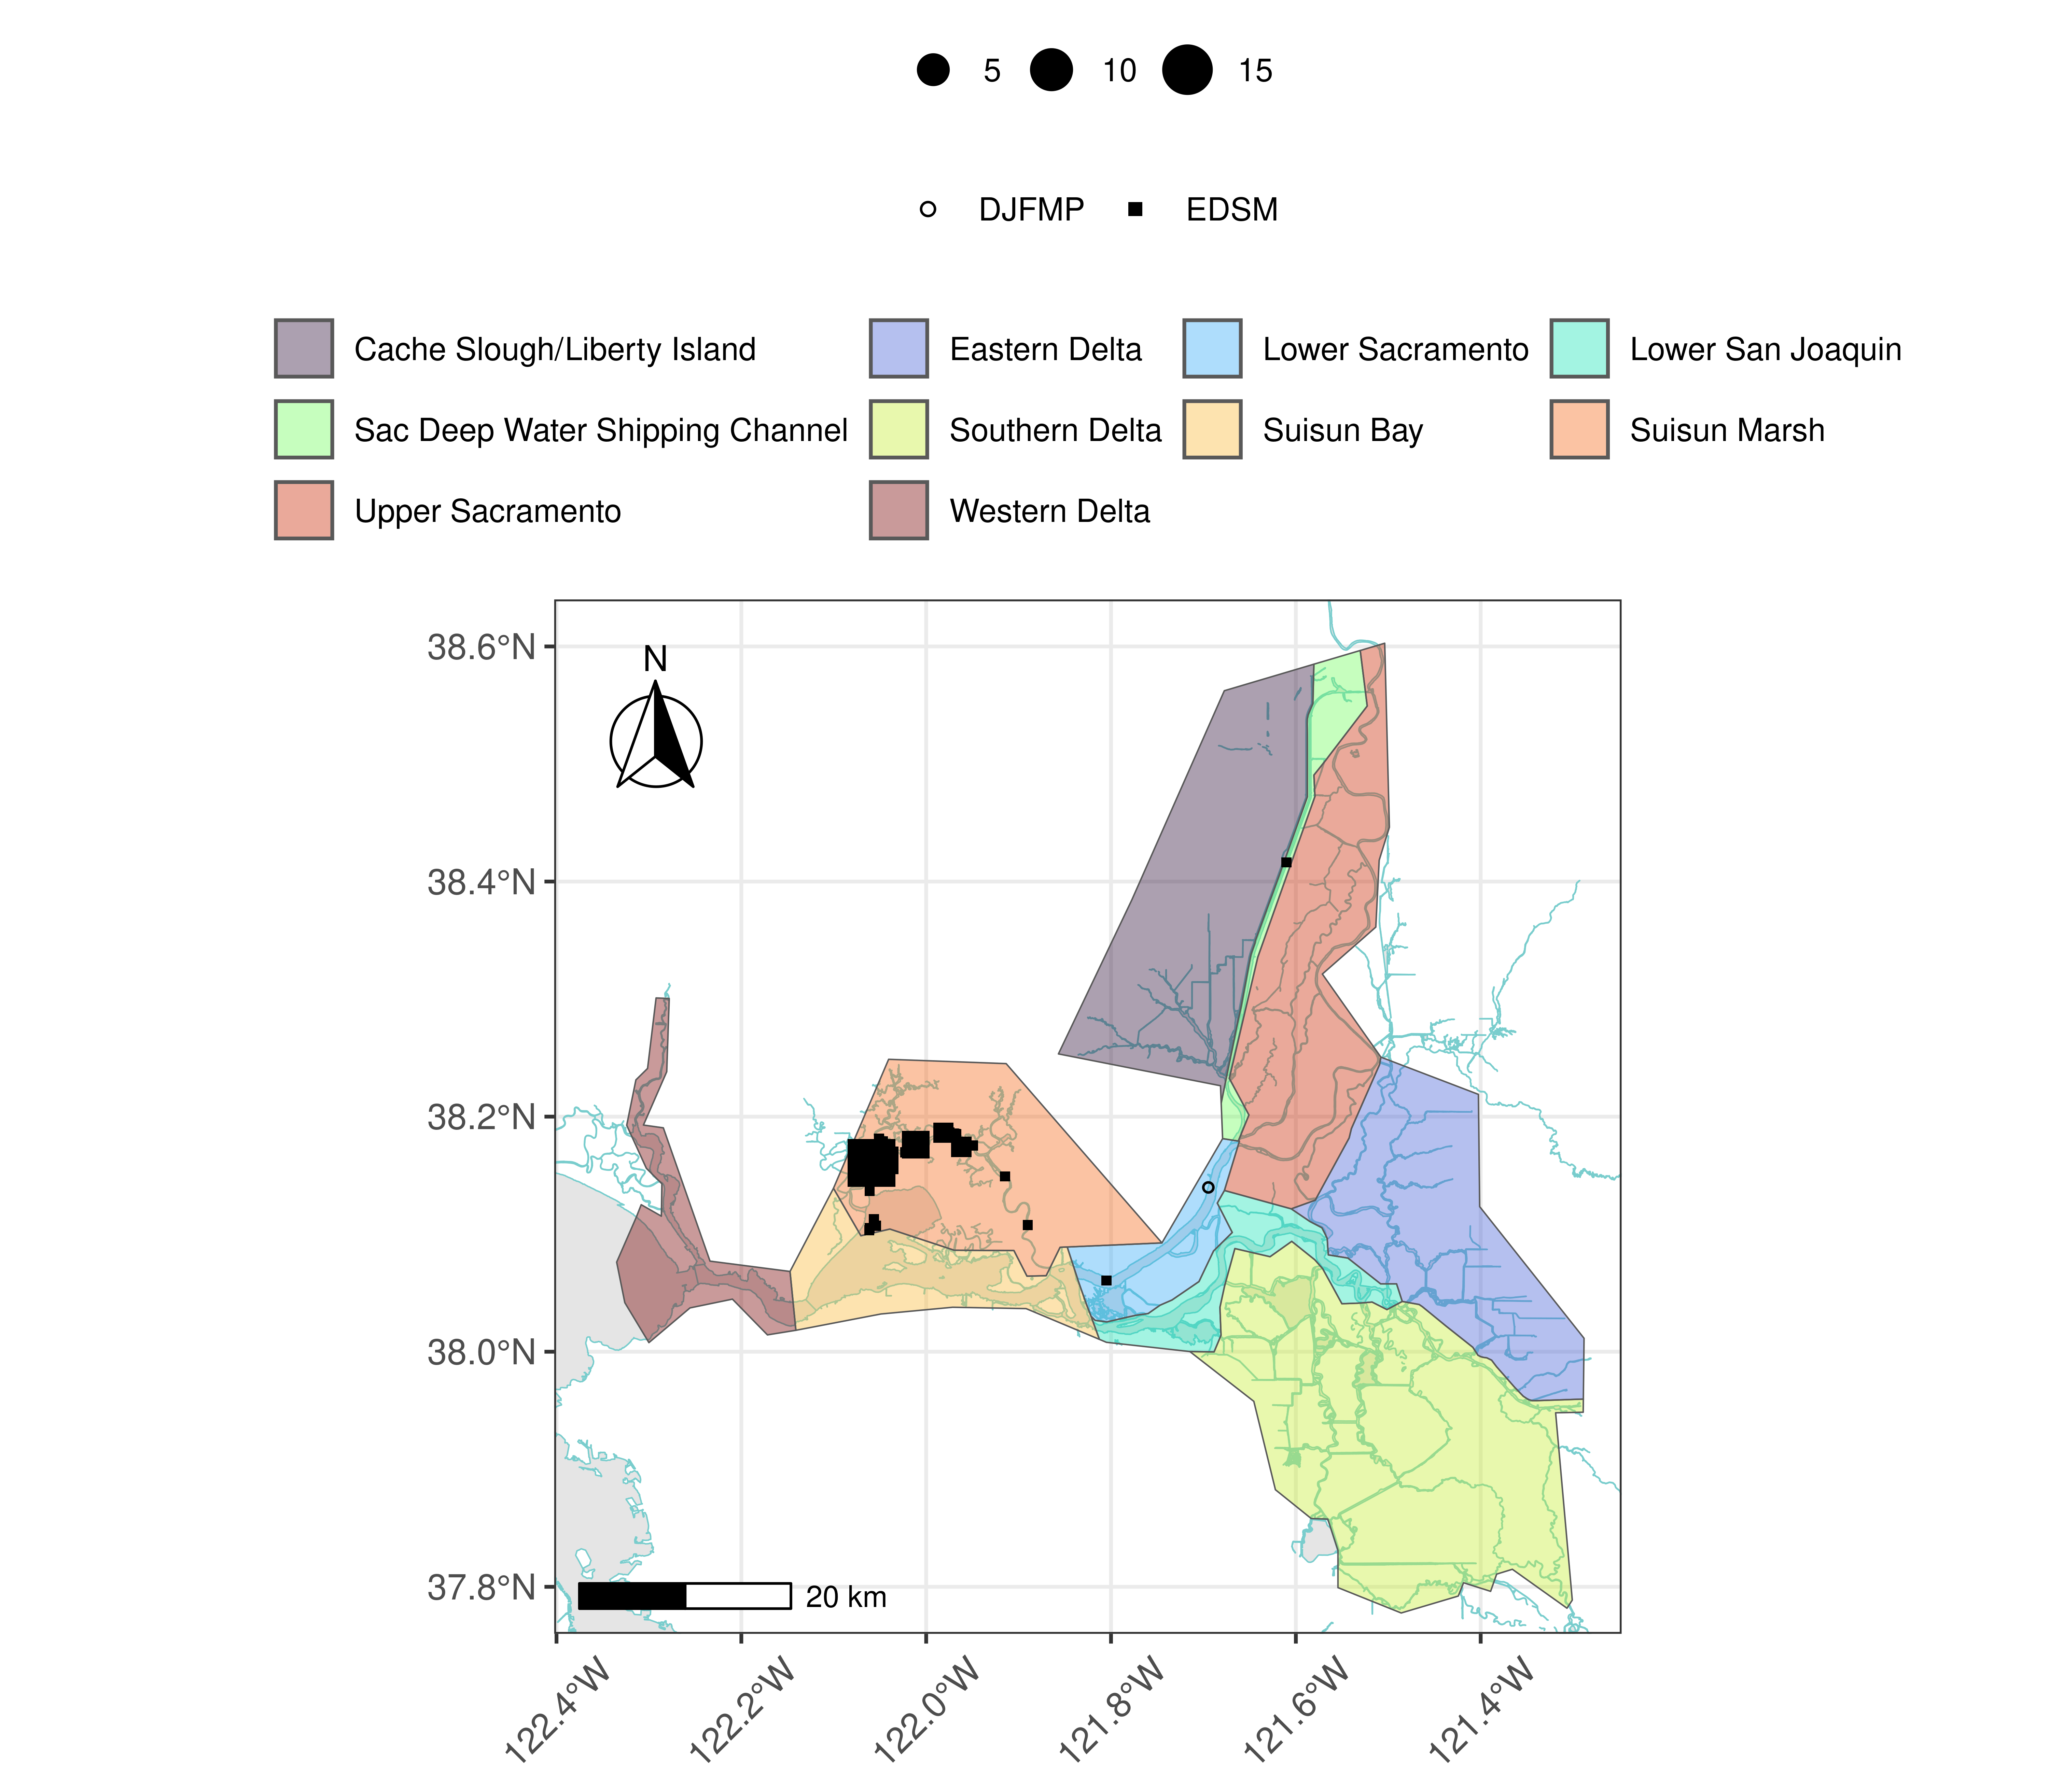
Figure 9: Delta smelt distribution for WY 2026
Table 8: Delta smelt water year totals by life stage
Survey | Region | Life Stage | Total
DJFMP | North | Juvenile | 1
EDSM | North | Adult | 1
EDSM | West | Adult | 32
EDSM | West | Juvenile | 23

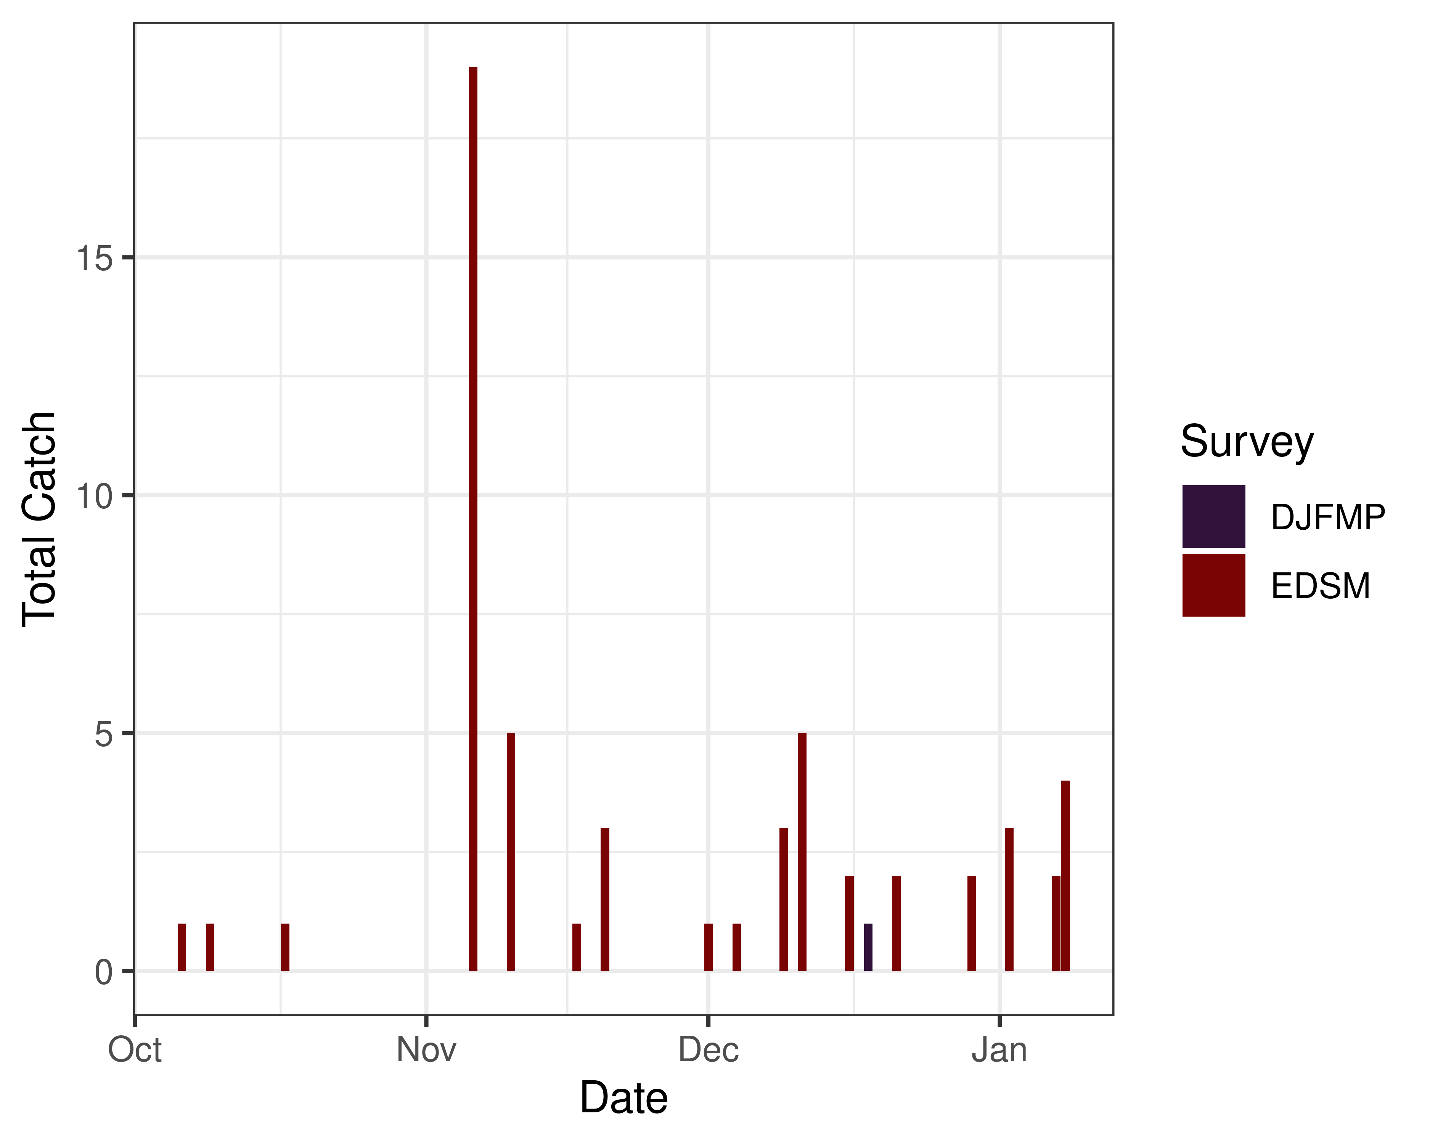
Figure 10: Time series of Delta smelt catch, WY 2026

3.2.2 Environmental

3.2.2.1 First Flush
Threshold: 3-day avg FPT flow ≥ 25,000 cfs and 3-day avg FPT turbidity ≥ 50 FNU
- FPT Flow (3-day average): 71297 cfs as of Jan 11, 2026
- FPT Turbidity (3-day average): 48.81 FNU as of Jan 11, 2026
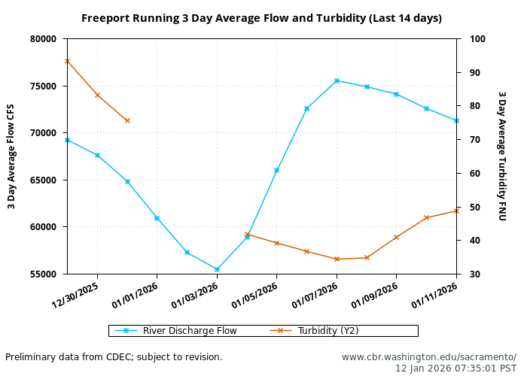

3.2.3 Real-time Assessment Thresholds

3.2.3.1 Adult Delta smelt
Threshold: If daily average JPF < 0 AND turbidity ≥ 12 FNU at OBI, HOL and OSJ
- JPF: 18,657 cfs as of Jan 08, 2026
- OBI Turbidity: 6.65, 6.76, 6.66 FNU as of Jan 11, 2026
- HOL Turbidity: 10.56, 8.52, 7.39 FNU as of Jan 11, 2026
- OSJ Turbidity: 15.15, 15.31, 18.22 FNU as of Jan 11, 2026
Offramp Adult/Onramp Larval and Juvenile Protections when RVB or SJJ > 12°C
- RVB temperature (3-day average): 10.19°C as of Jan 11, 2026
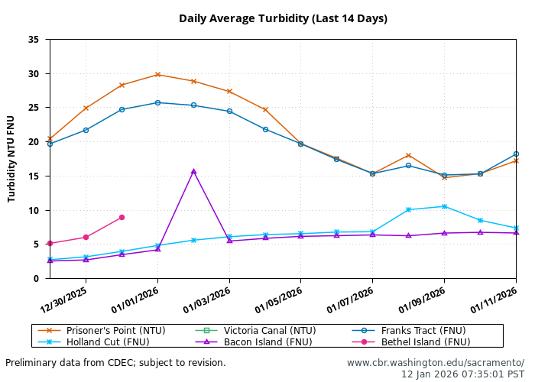
- See Bay-Delta Live for recent Delta-wide turbidity conditions.

3.2.3.2 Larval/juvenile Delta smelt
Threshold: After the onset of spawning, if JPF < 0 cfs AND turbidity is ≥ 12 FNU in the south Delta AND PTM modeling indicates the action would avoid ≥ 5% entrainment of Delta smelt population after 30 days
- 12-station South Delta Turbidity: The most recent average turbidity was 19.1 FNU as of Dec 30, 2025

3.2.4 Evaluation
Delta smelt:
- After the start of entrainment management, is JPF < 0 and is daily average turbidity ≥ 12 FNU in the OMR corridor (stations OBI, HOL, and OSJ)?
- No, these conditions will not be met this week.
- Has the average water temperature at Jersey Point or Rio Vista not exceeded 53.6°F (12°C) for 3 consecutive days and/or has this action already been taken during WY 2026?
- Temperature at Rio Vista or Jersey Point has not exceeded the threshold. The Delta smelt adult entrainment management action has not yet been taken in WY 2026.
- What is the evidence for the onset of Delta smelt spawning?
- Upstream migration for Delta smelt occurs between September and December and in response to “first flush” conditions (Sommer et al. 2011, Grimaldo et al. 2009). Migration typically ranges one to four weeks after flow and turbidity increases, based on salvage data (Sommer et al. 2011). Historically, detections of ripe Delta smelt began in January and peaked in February and March and the majority of Delta Smelt spawning occurs within a temperature range of 9-18˚C (Damon et al. 2016). Based on historical monitoring data from the past few years, first detection of larvae in the Central and South Delta has typically occurred by mid to late March. Based on historic data the migration is likely occurring now, and the onset of spawning has likely not yet occurred.
- After the onset of spawning, have the following conditions occurred: JPF < 0, daily average turbidity is ≥12FNU in the South Delta, and PTM modeling indicates OMRI no more negative than -3500 cfs for at least 7 days would avoid ≥5% entrainment of the Delta smelt population at facilities after 30 days?
- The onset of spawning is unlikely to have occurred and JPF is not < 0 cfs.

3.3 Longfin smelt

3.3.1 Biological
- Longfin smelt life stages: Adult, Juvenile, NA, Larva
- Longfin smelt count: 277 adult, 439 juvenile, and 10 larval longfin smelt have been detected this water year. See Table 9 for recent detections, Figure 11 for spatial distribution, and Figure 12 for temporal distribution.
- Longfin smelt salvage: 0 longfin smelt have been salvaged, and the cumulative seasonal salvage is 0.
Table 9: Longfin smelt detections in the last 2 weeks. Fork Length > 84mm = Adult, Fork Length 20-84mm = Juvenile, Fork Length < 20mm = Larva.
Survey | Date | Region | Stratum | Life Stage | Catch
DJFMP | 2025-12-30 | N/A | Chipps Island | Adult | 54
DJFMP | 2025-12-30 | N/A | Chipps Island | Juvenile | 1
DJFMP | 2025-12-31 | N/A | Chipps Island | Adult | 44
DJFMP | 2025-12-31 | N/A | Chipps Island | Juvenile | 2
DJFMP | 2026-01-05 | N/A | Chipps Island | Adult | 1
DJFMP | 2026-01-06 | N/A | Chipps Island | Adult | 1
DJFMP | 2026-01-08 | N/A | Chipps Island | Adult | 3
EDSM | 2025-12-30 | West | Suisun Bay | Adult | 2
EDSM | 2025-12-30 | West | Suisun Bay | Juvenile | 1
EDSM | 2025-12-31 | Far West | Suisun Bay | Adult | 2
EDSM | 2025-12-31 | Far West | Suisun Bay | Juvenile | 1
EDSM | 2026-01-05 | Far West | Suisun Bay | Adult | 2
EDSM | 2026-01-05 | Far West | Suisun Bay | Juvenile | 2
EDSM | 2026-01-06 | West | Suisun Bay | Juvenile | 1
EDSM | 2026-01-07 | West | Suisun Marsh | Juvenile | 1
sls | 2025-12-30 | Far West | Western Delta | Larva | 3
sls | 2025-12-30 | Far West | Western Delta | NA | 4
sls | 2025-12-30 | West | Lower San Joaquin | Larva | 4

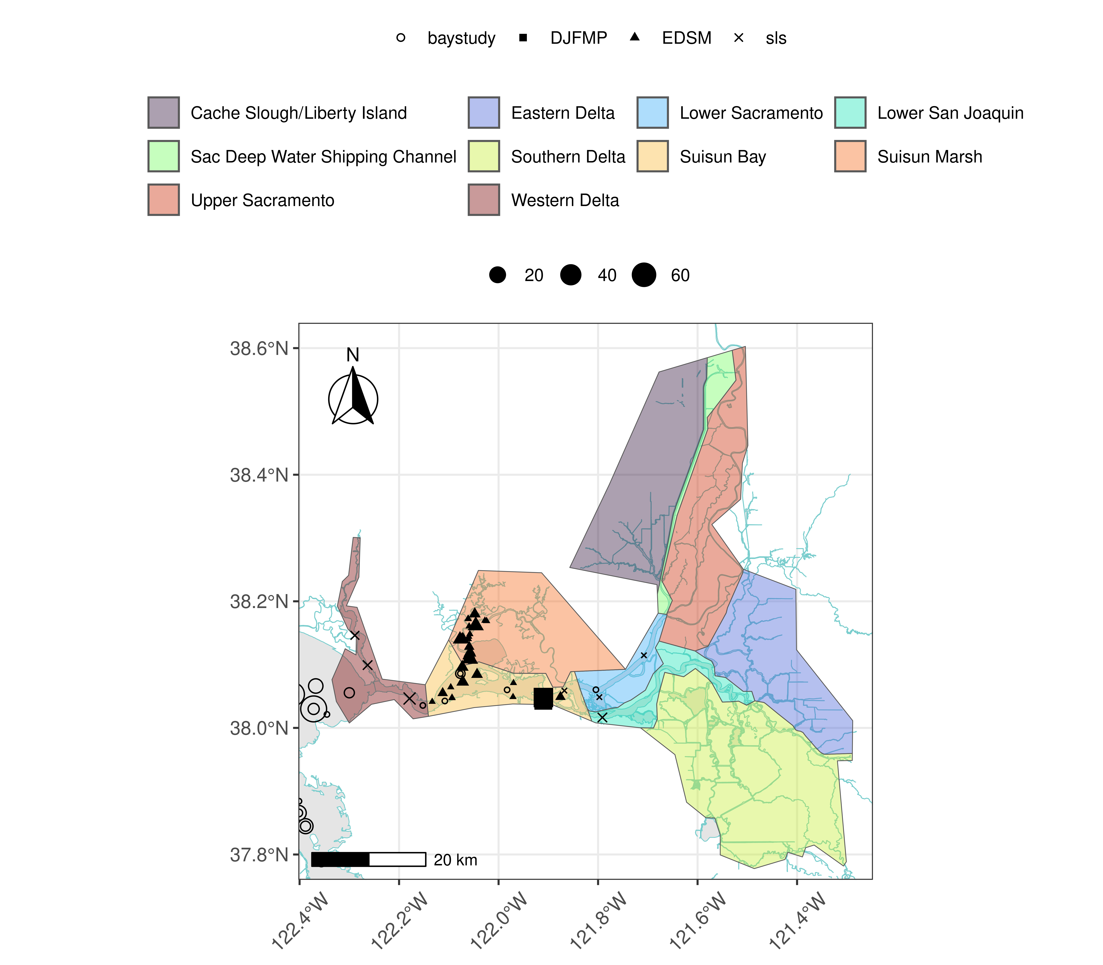
Figure 11: Longfin Smelt Distribution for WY 2026
Table 10: Longfin smelt water year totals by life stage
Survey | Region | Life Stage | Total
DJFMP | N/A | Adult | 240
DJFMP | N/A | Juvenile | 14
EDSM | Far West | Adult | 7
EDSM | Far West | Juvenile | 13
EDSM | West | Adult | 22
EDSM | West | Juvenile | 75
baystudy | Bay | Adult | 6
baystudy | Bay | Juvenile | 320
baystudy | Far West | Adult | 2
baystudy | Far West | Juvenile | 11
baystudy | West | Juvenile | 6
sls | Far West | Larva | 3
sls | North | Larva | 1
sls | West | Larva | 6

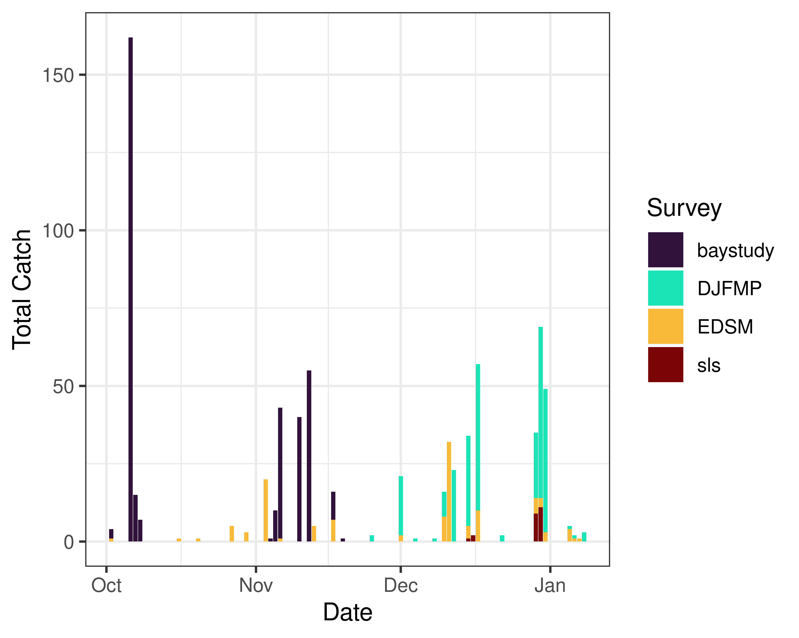
Figure 12: Time series of longfin smelt catch, WY 2026

3.3.2 Real-time Assessment Thresholds

3.3.2.1 Start of Entrainment Management (Adult Longfin Smelt)
- Not relevant

3.3.2.2 Adult longfin smelt
- Threshold: JPF < 0 cfs, annual loss is on a trajectory to exceed 5% of the adult population abundance, and reduced exports will reduce entrainment in the south Delta
  - Daily average JPF: 18,657 cfs as of Jan 08, 2026
  - Water year total adult longfin smelt salvage = 0

3.3.2.3 Larval/juvenile longfin smelt
- Threshold: JPF < 0 cfs AND population model demonstrates need to reduce entrainment to avoid population decline
  - Daily average JPF: 18,657 cfs as of Jan 08, 2026

3.3.3 Evaluation
Longfin smelt:
- If JPF < 0, what is the trajectory of annual loss of adult longfin smelt and is it likely to exceed 5% of the adult population estimate? Is South Delta entrainment expected to decrease due to a reduction in export pumping?
- JPF is not < 0 cfs and we have not detected any adult longfin smelt in salvage. The ZOI analysis indicates little change in the hydrodynamic footprint between current and forecasted flows this week. The analysis showed a 65 km difference in hydrodynamic footprint between OMRI of –3500 cfs and –5000 cfs, indicating a low risk of entrainment.
- For larval and juvenile longfin smelt, if JPF < 0 cfs, do particle tracking models show a moderate to high difference in particle fates across different OMRI scenarios? Does Zone of Influence modeling show moderate to high changes in hydrodynamic footprint across different OMRI scenarios? Are these effects anticipated to cause a population decline?
- JPF is not less than zero. No PTM was run this week. ZOI modeling shows moderate changes in hydrodynamic footprint between OMRI scenarios.
- Is there additional information or other analyses that should be considered in this evaluation?
- Additional information may be discussed if needed at the DAT call.

3.4 End of smelt Entrainment Management
- Not relevant

3.5 References

